**Now please answer the following questions:**

1. Which pins on the Nucleo F303RE can be used to read analog values?
   1. A0 to A5
2. As soon as the ‘adc’ pins is read, what is the minimum and maximum voltage that will be measured?
3. How many bits does the ADC of the Nucleo F303RE have? Check the datasheet!
   1. 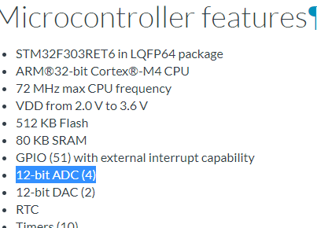  
        
      12-Bit!
4. Which value corresponds to the minimum voltage and which value corresponds to the maximum voltage of the ‘adc’ pins?

Answer the following questions, build a circuit, and write a program that can determine the ambient temperature:

1. What is the resistance of the thermistor at 25 degrees Celsius?
2. Which reference resistor are you going to use (multiple answers possible)?
3. Draw your circuit using Fritzing.